Release Notes

BasList 2.0.0 for BasTools 1.0.0
This document summarises the changes since 1.1.0.
BasList 1.1.0 and earlier was a standalone utility. This version is incorporated into BasTools and offers numerous improvements.

Enhancements
BasList requires .Net 10.0 or later (https://dotnet.microsoft.com/en-us/download/dotnet/10.0)

Prettyprint and Formatting Changes
/prettyprint in 1.1.0 both coloured syntax and added ‘legibility’ spaces. In 2.0.0, /prettyprint only colourises, meaning that the full formatting options are also available to the plain text listing if colours are not wanted.
As a reminder, the full list of colours is:
Token type | Colour
Keyword e.g. PRINT | Blue
Variable (except @% and pseudo-variables)  Arrays | Magenta  Dark magenta
PROC or FN name | Cyan
Literal string  ARM registers (R0, R1, PC, SP etc.) | Green
REM | Yellow / Brown
Mathematical operators (+-/*=<>^) (but not ? ! $) | Red
GOTO / GOSUB / ON line numbers | Dark grey (changed from 1.1.0)
Line numbering | Dark grey
All else, e.g. literal numbers, hex numbers, * commands, separators | White / Black
/nospaces is renamed /noformat (default: OFF). If specified, line numbers will not have a following space and legibility spaces will not be added. The default is to separate line numbers (if used) from the code and space out keywords etc. to aid reading dense code. BasList 2.0.0 substantially improves this over 1.1.0, normalising the code by removing extraneous spaces and adding where needed, while preserving REMs and assembler comments. Lists, brackets and unary minus are correctly spaced.
If /noformat is specified, the program is listed as originally entered.
/noformat no longer cancels /indent.
/indent – now not only indents loops – now including WHILE … ENDWHILE – but also CASE and multiline IF … THEN … ELSE statements in Basic V. It may also indent the body of PROCs and FNs. See ReadMe.
/breakapart is renamed /splitlines. It now properly indents line sections and splits at ELSE as well as colons. This can greatly improve the legibility of long single-line IF statements. You are reminded, though, that single-line and multiline IF statements work differently. Don’t be fooled by the multiline appearance! You are strongly advised not to suppress line numbers when /splitlines is in use.
/V (Basic V) – BasList now dynamically switches it on if it encounters two-byte tokens in Acorn-format programs. Note, however, that should, say, some ARM assembler or a multiline IF structure precede any Basic V keyword, BasList might not handle it correctly. You are therefore advised to use /V. If in doubt, try without and observe the header that precedes the listing.
BasList no longer displays Basic V keywords as their 8-bit equivalent, e.g. LOADCOUNT instead of TINT. Such commands cannot legitimately be used in a program in any case.
/notBasicV – Overrides automatic Basic V detection. Useful for programs written for use on both 8-bit and RiscOS machines that include 6502 assembler.
/clear and /cls – Clear the console window before listing. Can be useful to prevent confusion with earlier listings in the same window. For example, Ctrl-Home will take you to the top of the latest listing.
/debug – displays each line with the original detokenised line, formatted line, line with syntax tags and formatted line with syntax tags. Best combined with /prettyprint.
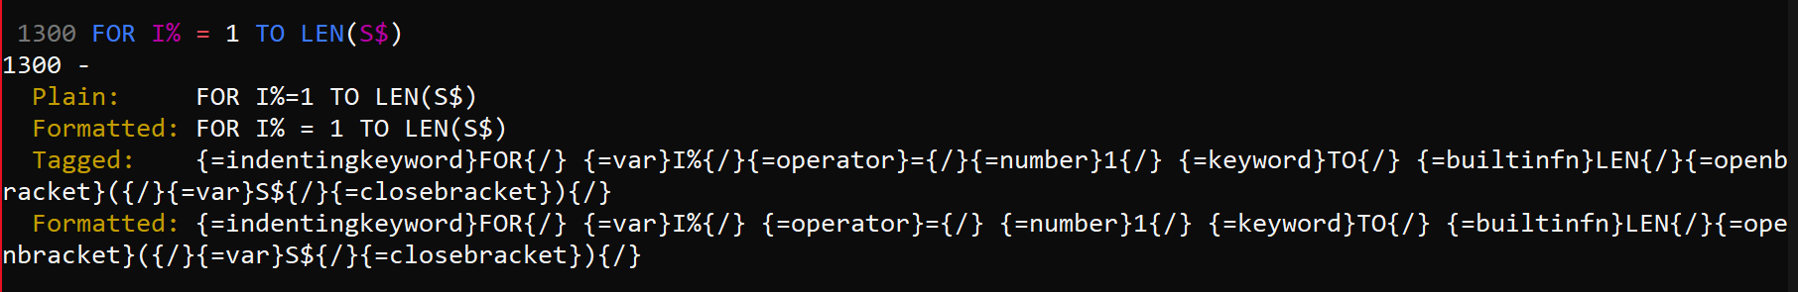
/saveddefaults – after parsing the command line, options are saved as defaults for next time. Excludes values that are specific to each run like filename, directives and line number limits. If /saveddefaults is present on the command line, any saved defaults will be updated.
To override a saved default, use /- (slash minus). Note that - is no longer an alternative to /
/resetdefaults – delete saved defaults.
/exporttagged – display the formatted tagged line only (see /debug above). This is provided for the benefit of anyone wanting to provide their own formatter or to perform analysis. Pipe to a file or program as required.
© Andrew Rowland 2022-2026

